**Chapter 2**

**PRESENTATION, ANALYSIS AND INTERPRETATION DATA**

1. **PRESENT SYSTEM**

**System Narrative**

The Bohol Island State University is a premiere Science and Technology University and composed of six campuses. One of the campuses is the Bohol Island State University – Balilihan Campus located at Magsija, Balilihan and bearing the flagship of Information Technology and it is molding into becoming a center of technology for the entire BISU System.

Currently there’s no such central place that students can easily communicate with each other and with their teachers especially when they are not inside the campus. Students should have to go to the campus to see if there are new announcements posted in the bulletin board. When a student is absent from the class he/she will have to go over a range of different social media or ask personally to his/her classmates if there are assignments or class announcements given by the instructor. Consequently, students continue to struggle to complete team projects that require contributions from other students.

Moreover, instructors consume more time and effort in posting an announcement to the bulletin board. Usb flash drives that are used by the instructors in sharing file may contain virus that may corrupt other files.

**Findings/Constraints**

35

The present system of Bohol Island State University – Balilihan Campus envisioned increasing its number of students in the future. BISU Balilihan Campus is currently using its manual process in terms of communication such as giving information or announcement to students. Students cannot get latest information directly concerning to their quizzes, exam dates, assignments and organization meetings.

On the other hand, many BISU students experiencing communication difficulties in their learning process, especially on how effectively communicate among themselves for group assignments, campus activities and general questions. They are also having trouble on how efficiently they can find and share information about scholarship, meetings and internship. It’s quite common that information they found are either inaccurate or out of date.

Therefore it is reasonable to make use of this advancement and develop a system that would specifically address the problems. The researchers came up with the idea of creating BISU Information Hub App a mobile messaging application that serves mainly for educational purposes and focuses on academic activities for the students and instructors of Bohol Island State University – Balilihan Campus.

**Context Diagram**

36

Students

- fetching information and announcements

Organization Officers

INSTRUCTOR

- sends information and announcements

- sends information and announcements

-

- fetching information and announcements

- fetching information and announcements

**Figure 4: Context Diagram of Manual Process**

**Event List**

37

1. **Instructors request for approval of information and announcements for posting**
2. **Instructors send information and announcements verbally**
3. **Instructors send information and announcements through social media.**
4. **Instructors shared file document.**
5. **SAO received information and announcements approval for posting.**
6. **Sao approved information and announcements for posting**
7. **Instructors received approved information and announcements for posting**
8. **Instructors post the approved information and announcements to the bulletin board.**
9. **Organization Officers request for approval of information and announcements for posting**
10. **Organization Officers received approved information and announcements for posting**
11. **Students request for approval of information and announcements for posting**
12. **Students received approved information and announcements for posting**

38

1. **Students post the approved information and announcements to the bulletin board**
2. **Students received information and announcements verbally**
3. **Students received information and announcements through social media**
4. **Students received file documents**

**Event Diagram**

Process of requesting approval of information and announcements for posting

Present System

Instructors

**Figure 5: Event 1.0: Instructors request for approval of information and announcements for posting**

Instructors

Process of sending information and announcements verbally

Present System

**Figure 6: Event 2.0: Instructors send information and announcements verbally**

Process of sending information and announcements through social media

Instructors

Present System

**Figure 7: Event 3.0: Instructors send information and announcements through social media**

Instructors

Process of sharing file documents

Present System

**Figure 8: Event 4.0: Instructors shared file documents**

39

Process of receiving information and announcements approval for posting

SAO

Present System

**Figure 9: Event 5.0: SAO received information and announcements approval for posting**

SAO

Process of approving information and announcements approval for posting

Present System

**Figure 10: Event 6.0: SAO approved information and announcements for posting**

Process of receiving approved information and announcements for posting

Instructors

Present System

**Figure 11: Event 7.0: Instructors received approved information and announcements for posting**

Process of posting approved information and announcements

Instructors

Present System

**Figure 12: Event 8.0: Instructors post the approved information and announcements the bulletin board**

Process of requesting approval of information and announcements for posting

Organization Officers

Present System

**Figure 13: Event 9.0: Organization Officers request for approval of information and announcements for posting**

Process of receiving approved information and announcements for posting

Organization Officers

Present System

**Figure 14: Event 10.0: Organization Officers received approved information and announcements for posting**

Process of requesting approval of information and announcements for posting

40

Students

Present System

**Figure 15: Event 11.0: Students request for approval of information and announcements for posting**

Process of receiving approved information and announcements for posting

Students

Present System

**Figure 16: Event 12.0: Students received approved information and announcements for posting**

Process of posting approved information and announcements

Students

Present System

**Figure 17: Event 13.0: Students post approved information and announcements to the bulletin board**

Process of receiving information and announcements verbally

Students

Present System

**Figure 18: Event 14.0: Students received information and announcements verbally**

Process of receiving information and announcements through social media

Students

Present System

**Figure 19: Event 15.0: Students received information and announcements through social media**

Process of receiving file documents

Students

Present System

**Figure 20: Event 16.0: Students received file documents**

1. **BISU INFORMATION HUB APP**

41

**System Rules**

After gathering all the data and information of the present system, the researchers had come up to develop a mobile messaging application the “BISU Information Hub App”. BISU Information Hub App is designed to improve student’s educational experiences while attending college. This app will not only provide a tool to improve student’s communication skills but also provide a guideline of how other students can get involved in similar projects and get latest information about campus activities and announcements.

For the instructor, they can easily send out reminders and easily give announcements into the announcement tab. They can also create a group specifically for that particular subject. Instructors send out reminders about an upcoming test, issue study guides, give announcements and homework assignment to students in the group that has created. It may improve the collaboration between students and instructors.

BISU Information Hub App can only give one account for every enrolled student in BISU Balilihan Campus. The student will input first his school id to checked if he is enrolled and after checking, if the student was enrolled it will continue to the register form with the required information such as the email address, and password and user name which will help the customization of the rest of the function. After the user registered, the user can now access and manipulate the app with their email address or username and password. After the login process the main menu will appear such as the Private Chat, Groups, Profile, Friends, Announcement, and Report Problem

The user can also search and join group chatting to communicate with everyone in the class or group. The user can send request to the group, but only the instructor that created the group can either accept or decline the request and has the ability to add members to the particular group. Once the user add into the group chat, they will then start to send and receive messages for that particular group .Only instructors can make or create groups to avoid unnecessary conversations inside the created groups and .And the instructor that has created the can also kick a member inside the group.

42

BISU Information Hub App can provide a user an easier way of to add other users as friends and when the user get a friend request it will automatically appear in the friend menu. The app also provide the function of private messaging to enable the user sending message to an individual student besides the group chatting. The application is designed to be user-friendly so that the user can do it independently even without the technical assistance from the developers.

**Context Diagram**

43

– Display conversations

– Display announcement

– Display friends and friend request

– Display groups, group members, group request

– Download files

– Confirmation of friend request and group request

– Start conversations

– Post, attach files, view and comment announcements

– View friends

–View, send, decline, and accept friend request

-View, create groups

–Accept, decline, and send request to a group

-Kick members

– Report problem

Student

– Start conversations

- View and comment announcements

– View friends

– View, send, decline and accept friend request

- View groups, group members

– Send request to a group

– Report problem

– Display conversations

– Display announcement

– Display friends and friend request

– Display groups, group, members

– Download files

– Confirmation of friend request and group request

Admin

Instructor

– Upload id – Manage Groups – Display Id

– Manage Reports – Manage User –Display Reports

– Manage Course -Display Course and Teachers

– Manage Teacher -Display All Users

**Figure 10: Context Diagram of the Proposed System**

**Event List**

1. **Admin Log-in into the web**
2. **Admin manages general announcements**
3. **Admin manages groups**
4. **Admin manages teachers**
5. **Admin manages students**
6. **Admin manages users**
7. **Admin manages reports**
8. **User create an account into the mobile app**
9. **User Login into the mobile app**
10. **User send, accept or decline friend request**
11. **User create conversations**
12. **Instructors create a group/s**
13. **Group owner can add and kick members**
14. **Send request to a group**
15. **Group Owner accept or decline group request**
16. **Instructors create group announcement/s**
17. **User comment to the announcements**
18. **User report a problem**

**Event Diagram**

Admin Log-in

Admin

Log-in

**Figure 13: Event 1.0: Process of Log-in**

post.tbl

Admin

Process of managing general announcements

**Figure 14: Event 2.0: Admin manages general announcements**

groups.tbl

Process of managing groups

Admin

**Figure 15: Event 3.0: Admin manages groups**

Admin

Process of managing teachers

teachers.tbl

**Figure 16: Event 4.0: Admin manages teachers**

Process of managing students

Admin

students.tbl

**Figure 17: Event 5.0: Admin manages students**

Process of managing users

users.tbl

Admin

**Figure 18: Event 6.0: Admin manages users**

report_issues.tbl

Process of managing reports

Admin

**Figure 19: Event 7.0: Admin manages reports**

students.tbl

User

Process of creating an account

**Figure 20: Event 8.0: Creating an account**

User

users.tbl

Process of User Login

**Figure 21: Event 9.0: User Log-in**

Process of sending, declining and accepting friend request

User

friendships. tbl

**Figure 22: Event 10.0: User send, decline and accept friend request**

User

Process of creating conversations

mc_messages.tbl

**Figure 23: Event 11.0: User create conversations**

Instructors

Process of creating group/s

groups.tbl

**Figure 24: Event 12.0: Instructors create group/s**

group_request.tbl

Group Owner

Process of accepting or declining group request

**Figure 25: Event 13.0: Group owner accepts or decline group request**

groups.tbl

Group Owner

Process of adding and kicking of group member/s

**Figure 26: Event 14.0: Group owner add and kick group members**

group_request.tbl

User

Process of sending request to a group

**Figure 27: Event 15.0: User sends request to a group**

posts.tbl

Instructors

Process of creating /posting announcements

**Figure 28: Event 16.0: Instructors create and post announcements**

comments.tbl

Process of comment

User

**Figure 29: Event 17.0: User comment to the announcements**

report_issues. tbl

User

Process of report

**Figure 30: Event 18.0: User create/send report**

announcements.tbl

Mobile

User Sign up

Admin upload id

groups.tbl

Password

Username

Log-in

users.tbl

conversations.tbl

­­­

Manage users

students.tbl

Instructors

Students

create conversations

User

create groups

create announcements

received

**Figure 31: Top Level Diagram of the Proposed System**

**Process Specification**

1. User create an account

Begin

Enter School_id

Submit

If School_id=”enrolled”

Input email

Input username

Input password

Else

Display “Id not available”

End if

End

1. User Log-in into the application

Begin

Input username = “username”

Input password = “password”

If username and password == “username and password”

Grant Access

Else

Display “These credentials do not match our records!

End if

End

1. Home

Begin

If menu == ‘A’

View private messages

If private messages is clicked

View conversations

Write message

Send Message

If add icon is clicked

Select image to send

Send image

End If

End

1. Groups

Begin

If menu == ‘B’

Display groups

If group is clicked

View group conversations

Write message

Send Message

If add icon is clicked

Select image to send

Send image

End If

View group announcements

If announcements is clicked

View content

If content has file attachment

Download file attachment

Write comment

Save Input

View members

Display group members

End

1. Profile

Begin

If menu == ‘C’

View profile

If log-out button is clicked

Back to Log-in form

End

1. Friends

Begin

If menu == ‘D’

View Friend Request

If Accept button is clicked

You are now friend

Else if cancel button is clicked

Cancel friend request

End if

View Friends List

If Friends List is clicked

View person’s profile

If Unfriend button is clicked

Remove friends from friends list

End

1. General Announcements

Begin

If menu == ‘E’

View general announcements

If announcements is clicked

View content

If content has file attachment

Download file attachment

Write comment

Save Input

End

1. Reports

Begin

If menu == ‘F’

Create Report

Input report title

Input description

Add screenshot

Save Input

End

**Database Design**

**Tables**

Table 1. **Post.tbl**. Information about the announcements of the campus.

|  |  |  |
| --- | --- | --- |
| NAME OF FIELDS | TYPE | DESCRIPTION |
| Id | Integer | Primary key |
| Title | Varchar | Title of the announcement |
| Body | Text | Body of the announcement |
| Type | Varchar | Type |
| User_id | Integer | User id |
| Extra_info | Text | End date of the announcement |
| File | Varchar | Attachment of the announcement |
| Global | Tinyint | Global |

Table 2. **Comments.tbl**. It shows comments on announcement.

|  |  |  |
| --- | --- | --- |
| NAME OF FIELDS | TYPE | DESCRIPTION |
| Id | Integer | Primary key |
| Body | Varchar | Comment |
| User_id | Integer | User id |
| Post_id | Integer | Post id |

Table 3. **group_user.tbl**. Group user.

|  |  |  |
| --- | --- | --- |
| NAME OF FIELDS | TYPE | DESCRIPTION |
| Id | Integer | Primary key |
| User_id | Integer | User id |
| Group_id | Integer | Group id |

Table 4. **Friendships.tbl**. Friendships

|  |  |  |
| --- | --- | --- |
| NAME OF FIELDS | TYPE | DESCRIPTION |
| Id | Integer | Primary key |
| Sender_type | Varchar | Sender type |
| Sender_id | Bigint | Sender id |
| Recipient_type | Varchar | Recipient type |
| Recipient_id | Bigint | Recipient id |
| Status | Tinyint | Status |

Table 5. **groups.tbl**. This table shows the information of the group created.

|  |  |  |
| --- | --- | --- |
| NAME OF FIELDS | TYPE | DESCRIPTION |
| Id | Integer | Primary key |
| Name | Varchar | Name of the group |
| Description | Varchar | Group description |
| Short_description | Varchar | Short description |
| User_id | Integer | User id |
| Private | Tinyint | Private |
| Conversation_id | Integer | Conversation id |

Table 6. **mc_messages.tbl**. It illustrates messages of the conversation.

|  |  |  |
| --- | --- | --- |
| NAME OF FIELDS | TYPE | DESCRIPTION |
| Id | Integer | Primary key |
| Body | Text | Message |
| Conversation_id | Integer | Conversation id |
| User_id | Integer | User id |
| Type | Varchar | Type |

Table 7. **mc_messages_notification.tbl**. Messages notification.

|  |  |  |
| --- | --- | --- |
| NAME OF FIELDS | TYPE | DESCRIPTION |
| Id | Integer | Primary key |
| Message_id | Integer | Message id |
| Conversation_id | Integer | Conversation id |
| User_id | Integer | User id |
| Is_seen | tinyint | Seen |
| Is_sender | tinyint | sender |

Table 8. **mc_conversations.tbl**. Conversations

|  |  |  |
| --- | --- | --- |
| NAME OF FIELDS | TYPE | DESCRIPTION |
| Id | Integer | Primary key |
| Private | Tinyint | Private |
| Data | Text | Data |

Table 9. **group_request.tbl**. Group request.

|  |  |  |
| --- | --- | --- |
| NAME OF FIELDS | TYPE | DESCRIPTION |
| Id | Integer | Primary key |
| User_id | Integer | User id |
| Group_id | Integer | Group id |

Table 10.**group_post.tbl**.It shows the announcement of the group.

|  |  |  |
| --- | --- | --- |
| NAME OF FIELDS | TYPE | DESCRIPTION |
| Group_id | Integer | Group id |
| Post_id | Integer | Post id |

Table 11. **users.tbl**. It shows registered users.

|  |  |  |
| --- | --- | --- |
| NAME OF FIELDS | TYPE | DESCRIPTION |
| Id | Integer | Primary key |
| Name | Varchar | Name of the user |
| Email | Varchar | Email of the user |
| Person type | Varchar | Person type |
| User status | Varchar | Account status |

Table 12. **mc_conversation_users.tbl**. Conversation user.

|  |  |  |
| --- | --- | --- |
| NAME OF FIELDS | TYPE | DESCRIPTION |
| User_id | Integer | User id |
| Conversation_id | Integer | Conversation id |

Table 13. **user_friendship_groups.tbl**. Friendship groups.

|  |  |  |
| --- | --- | --- |
| NAME OF FIELDS | TYPE | DESCRIPTION |
| Friendship_id | Integer | Friendship id |
| Friend_type | Varchar | Friend type |
| Friend_id | Bigint | Friend id |
| Group_id | Integer | Group id |

**Functional Requirements**

List of inputs in the user.

|  |  |  |  |
| --- | --- | --- | --- |
| Input | Valid | Invalid Data | Error Remarks |
| Username | Character | Unregistered username |  |
| Password | Character | Unregistered password | Check Password |

List of inputs in the course.

|  |  |  |  |
| --- | --- | --- | --- |
| Input | Valid | Invalid Data | Error Remarks |
| Code | Character | No Inputs | Course code already exist |
| Course name | Character | No inputs | This field is required |
| Description | Character | No Inputs | This field is required |

List of inputs in announcements

|  |  |  |  |
| --- | --- | --- | --- |
| Input | Valid | Invalid Data | Error Remarks |
| End date | Date | None | Invalid Date |
| Attachment | Character | No Inputs |  |
| Title | Character | No Inputs | Please fill out this field |
| Description | Character | No Inputs | Please fill out this field |
| Body | Character | No Inputs | Please fill out this field |

List of inputs in the teachers

|  |  |  |  |
| --- | --- | --- | --- |
| Input | Valid | Invalid Data | Error Remarks |
| Profile picture | Character | None |  |
| First name | Character | No inputs | This field is required |
| Middle name | Character | No inputs | This field is required |
| Last name | Character | No Inputs | This field is required |
| Date of Birth | Date | No Input | Invalid date |
| Gender | Character | None | This field is required |
| Teachers ID | Character | No Input | This field is required |

List of inputs in the students

|  |  |  |  |
| --- | --- | --- | --- |
| Input | Valid | Invalid Data | Error Remarks |
| Profile picture | Character | None |  |
| First name | Character | No inputs | This field is required |
| Middle name | Character | No inputs | This field is required |
| Last name | Character | No Inputs | This field is required |
| Date of Birth | Date | No Input | Invalid date |
| Gender | Character | None | This field is required |
| Student ID | Character | No Input | This field is required |

List of inputs in the teachers

|  |  |  |  |
| --- | --- | --- | --- |
| Input | Valid | Invalid Data | Error Remarks |
| Profile picture | Character | None |  |
| First name | Character | No inputs | This field is required |
| Middle name | Character | No inputs | This field is required |
| Last name | Character | No Inputs | This field is required |
| Date of Birth | Date | No Input | Invalid date |
| Gender | Character | None | This field is required |

**Database Schema**

|  |
| --- |
| Id |
| Private |
| data |

|  |
| --- |
| User_id |
| Conversation_id |

|  |
| --- |
| Id |
| Body |
| Conversation_id |
| User_id |
| Type |

|  |
| --- |
| Id |
| Message_id |
| Conversation_id |
| User_id |
| Is_seen |
| Is_sender |
| Flagged |

|  |
| --- |
| Id |
| Body |
| User_id |
| Post_id |
| type |

|  |
| --- |
| Id |
| User_id |
| Group_id |

|  |
| --- |
| Id |
| User_id |
| Group_id |

|  |
| --- |
| Group_id |
| Post_id |

|  |
| --- |
| Id |
| Name |
| Email |
| Type |
| Status |

|  |
| --- |
| Id |
| Name |
| Description |
| Short_description |
| User_id |
| Private |
| Conversation_id |

|  |
| --- |
| Id |
| Title |
| Body |
| Type |
| User_id |
| Extra_info |
| File |
| Global |

|  |
| --- |
| Friendship_id |
| Friend_type |
| Friend_id |
| Group_id |

|  |
| --- |
| Id |
| Sender_type |
| Sender_id |
| Recipient_type |
| Recipient_id |
| status |

Mc_conversations

Group_user

comments

Mc_messages

User_friendship_groups

Group_request

Mc_conversation_user

Group_post

friendships

users

Groups

post

Mc_message_notification

Figure 32: Database Schema

Test Data/Cases

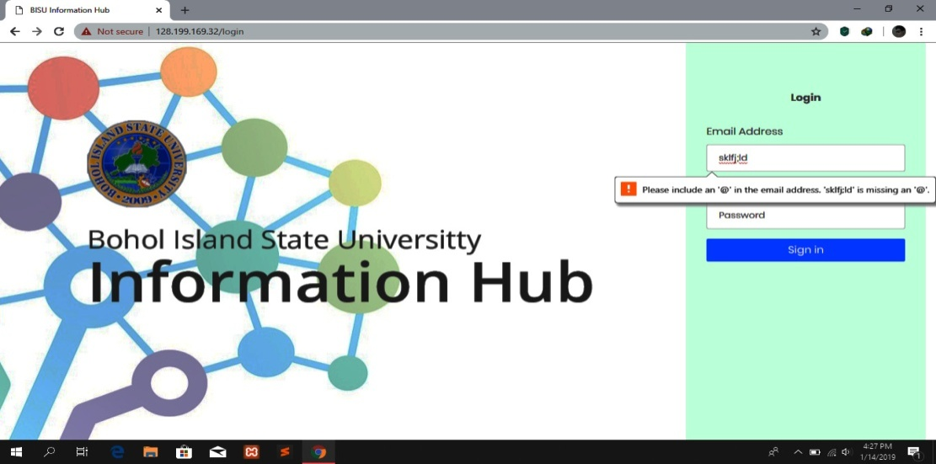

Preview 1: admin_login

Test case 1: Admin Login

Scenario 1: Input invalid email

Input: Invalid email

Process: Web app cannot be accessed

Output: Please include an ‘@” in the email address

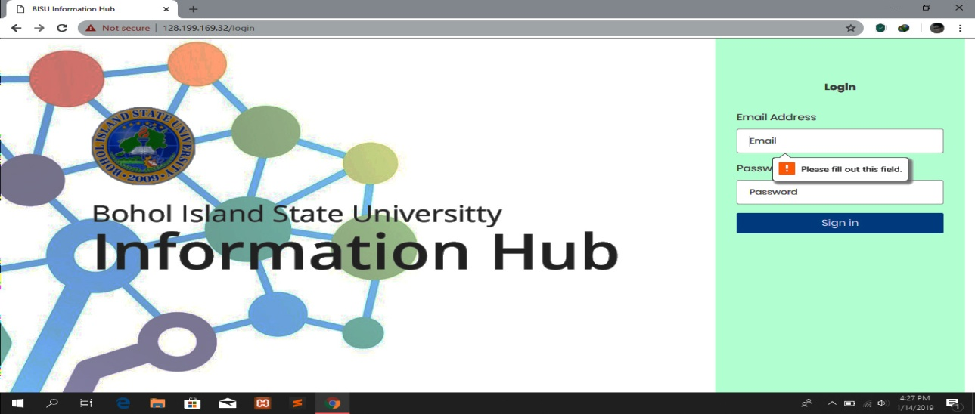

Preview 2: admin_login

Scenario 2: Login With empty fields

Input: Fill up with an empty fields

Process: Web App cannot be accessed

Output: Please fill out this fields

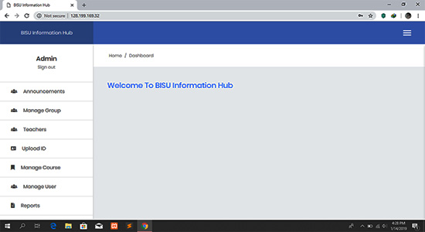

Preview 3: admin_login

Scenario 3: Valid email and password

Input: Fill up with valid email and password

Process: Web application accessed

Output: Welcome To BISU Information Hub

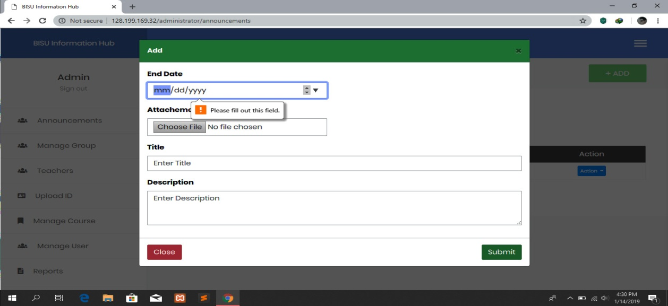

Preview 4: Creating general announcements

Test case 2: Create general announcements

Scenario 1: Submit with empty fields

Input: Fill up with an empty fields

Process: Scanning the text fields

Output: Please fill out this fields

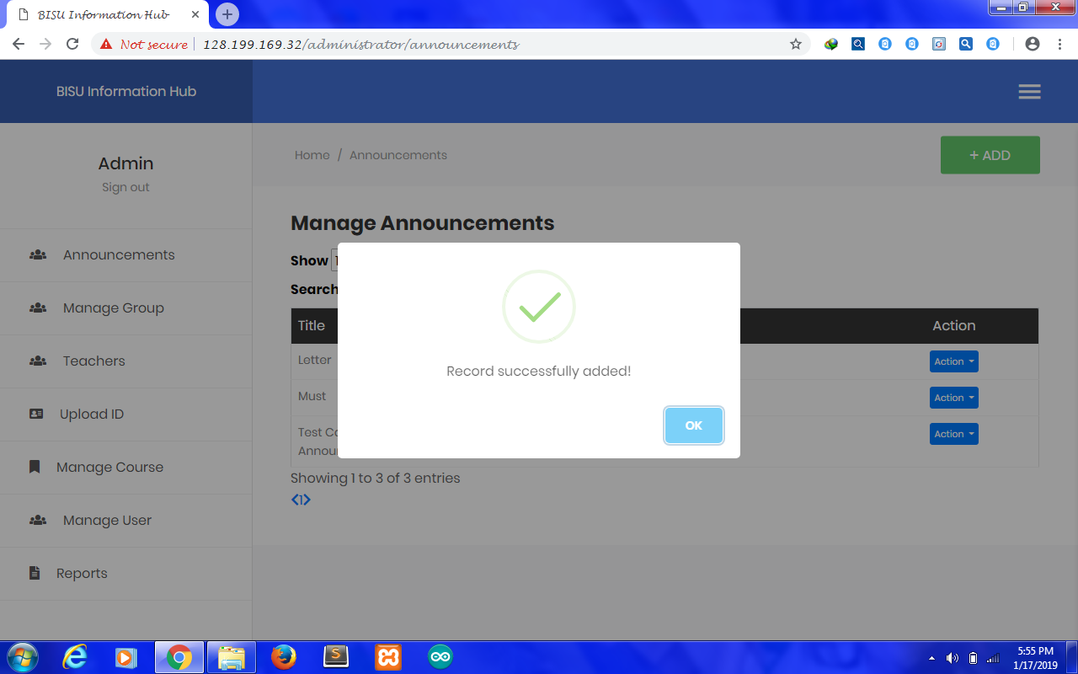

Preview 5: Creating general announcements

Scenario 2: Submit with valid data

Input: Fill up all fields with valid data

Process: Scanning the text fields

Output: Record successfully added

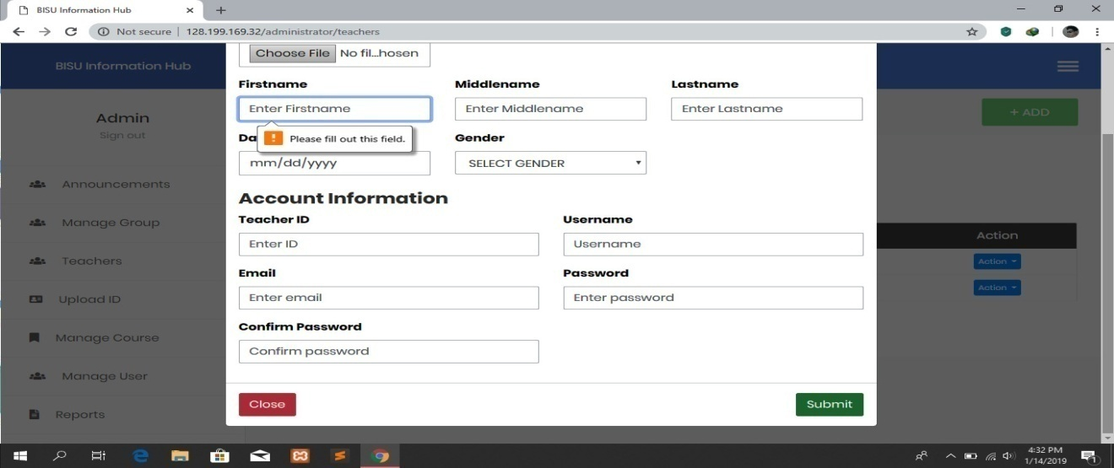

Preview 6: Creating teachers account

Test case 3: Create teachers account

Scenario 1: Submit with empty fields

Input: Fill up with an empty fields

Process: Scanning the text fields

Output: Please fill out this fields

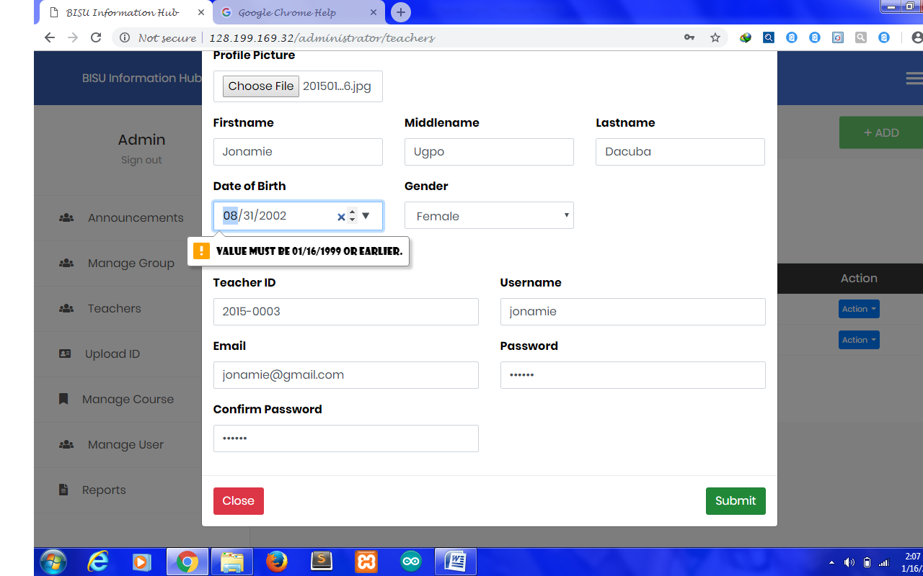

Preview 7: Creating teachers account

Scenario 2: Date of birth not equal to 20 years or above

Input: Fill up with a value above 01/16/1999

Process: Scanning text fields

Output: Value must be 01/16/1999 or earlier

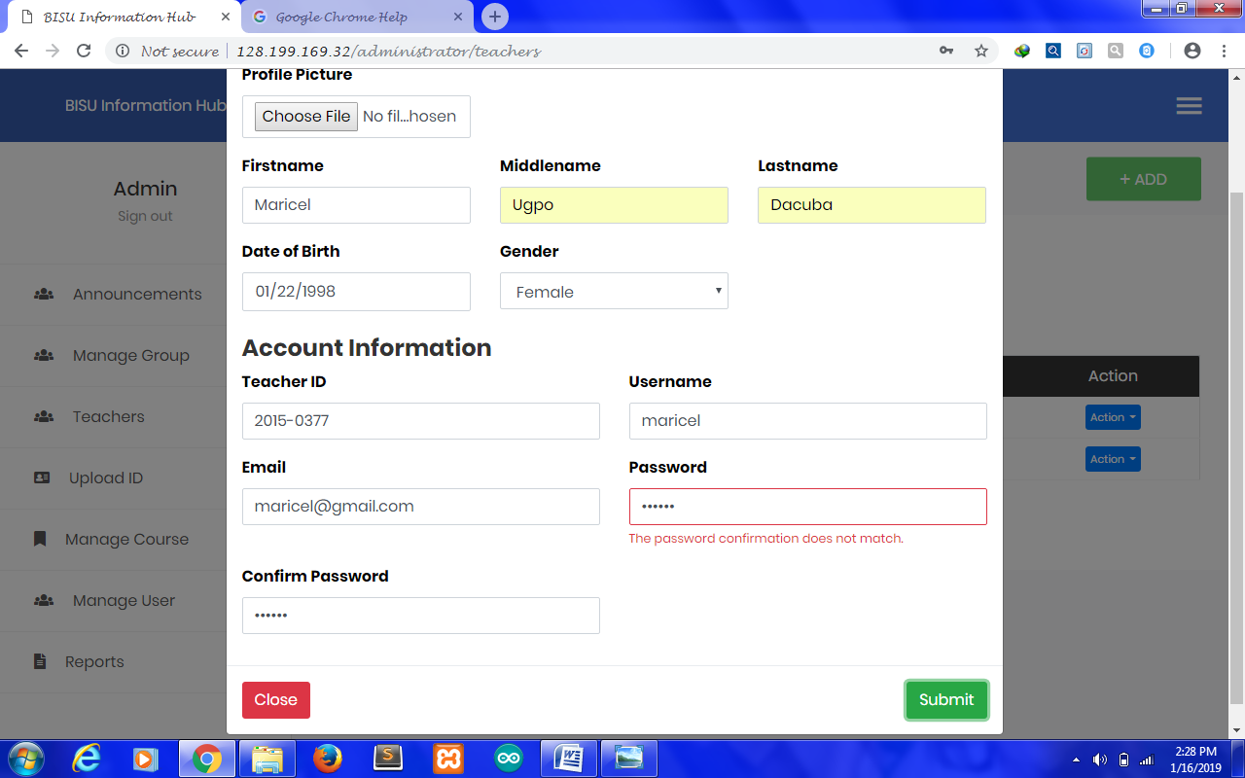

Preview 8: Creating teachers account

Scenario 3: Submit with not the same password and confirmation password

Input: Fill up with not the same password and confirmation password

Process: Scanning text fields

Output: The password confirmation does not match

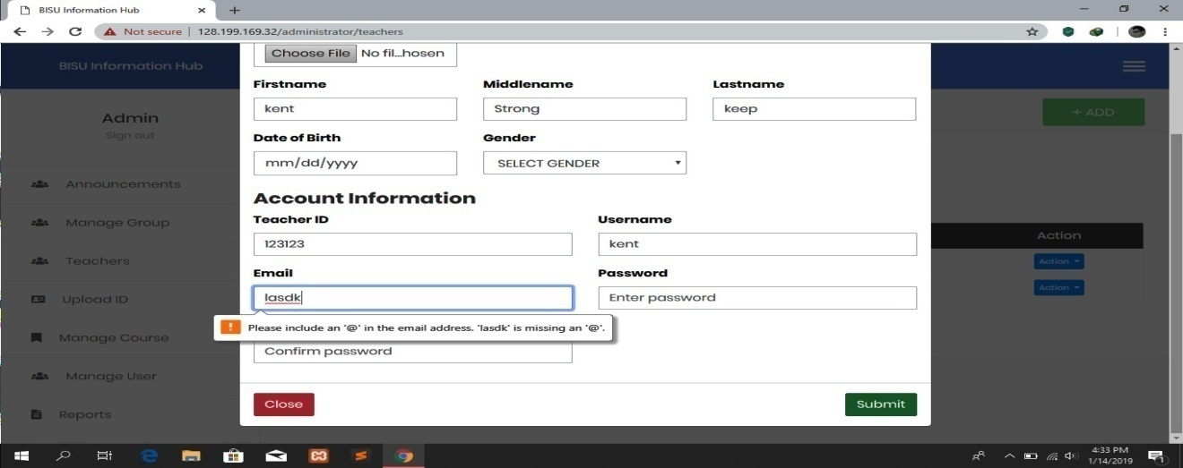

Preview 9: Creating teachers account

Scenario 4: Invalid email address

Input: Fill up with an invalid email

Process: Scanning the text fields

Output: Please include an ‘@’ in the email address

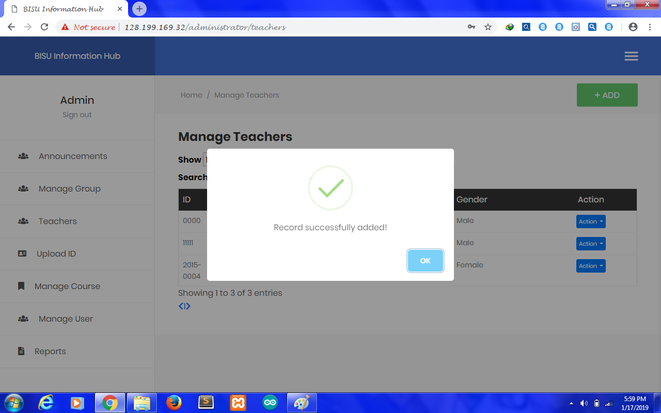

Preview 10: Creating teachers account

Scenario 5: Valid data

Input: Fill up all fields with valid data

Process: Scanning the text fields

Output: Record successfully added

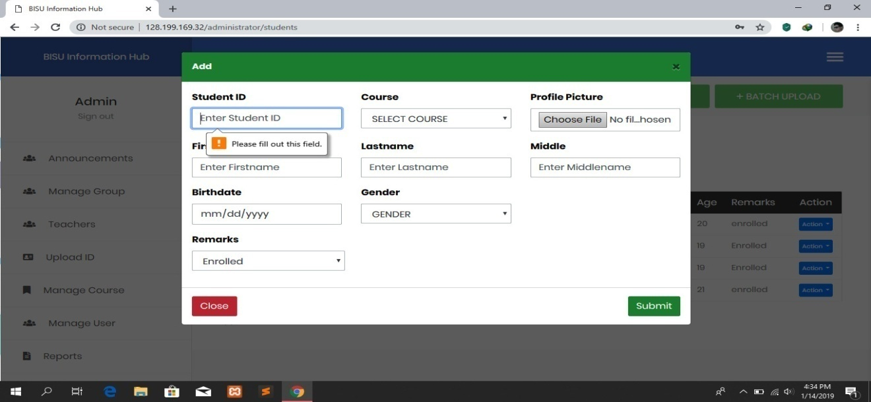

Preview 11: Add Student

Test case 3: Add student record

Scenario 1: Submit with empty fields

Input: Fill up with an empty fields

Process: Scanning the text fields

Output: Please fill up this field

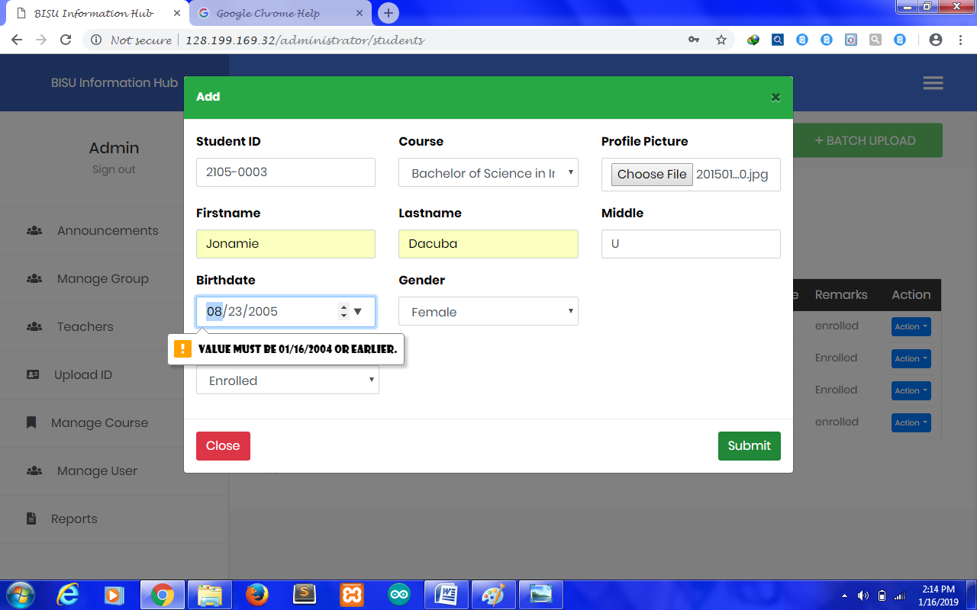

Preview 12: Add student

Scenario 2: Date of birth not be equal to 15 years or above

Input: Fill up with a value above 01/16/2004

Process: Scanning text fields

Output: Value must be 01/16/2004

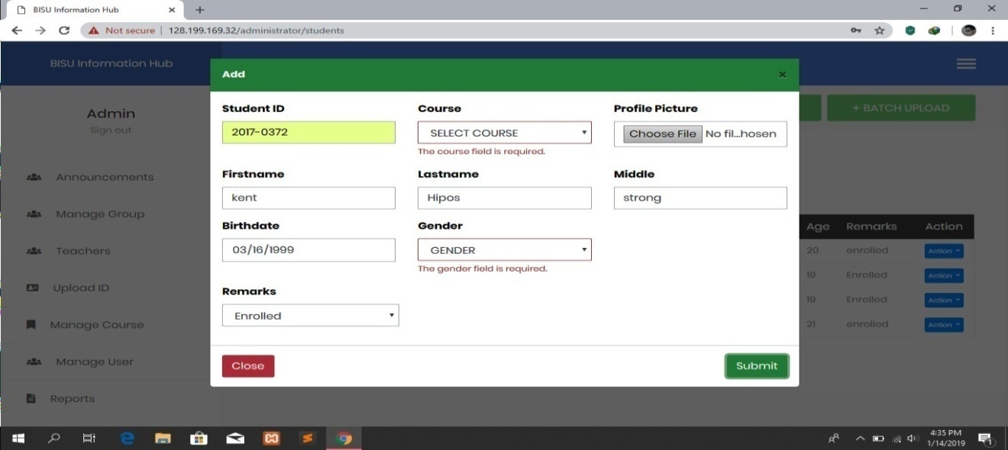

Preview 13: Add student

Scenario 3: Empty course field

Input: Fill up with an empty course field

Process: Scanning text fields

Output: The course field is required

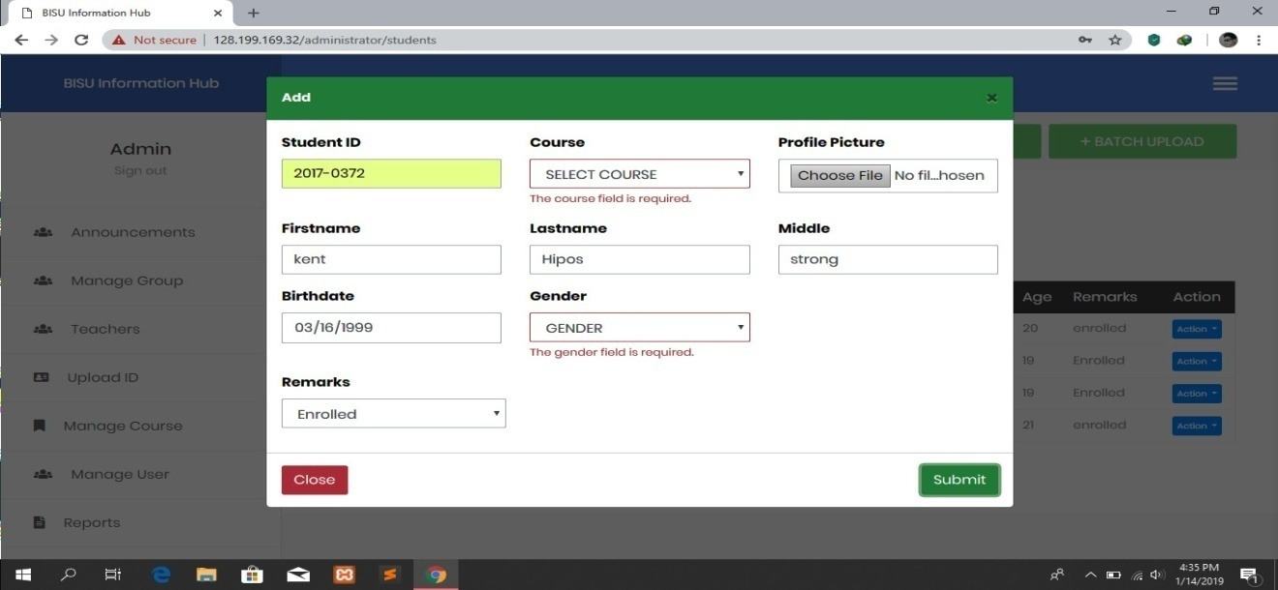

Preview 14: Add student

Scenario 4: Empty gender field

Input: Fill up with an empty gender field

Process: Scanning text fields

Output: The gender field is required



Preview 15: Add student

Scenario 5: Valid data

Input: Fill up all fields with valid data

Process: Scanning the text fields

Output: Record successfully added

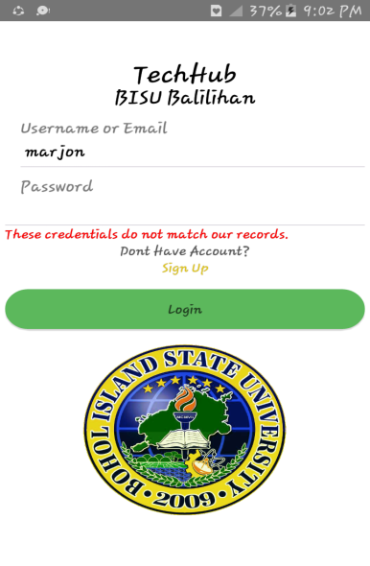

Preview 16: User Log in into mobile

Test case 4: Login into mobile app

Scenario 1: Wrong password

Input: Wrong entry will be invalid

Process: Scanning text fields

Output: These credentials do not match our records

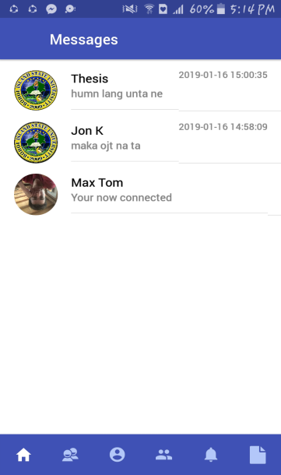

Preview 17: User log in

Scenario 2: Registered email and password

Input: Fill up with registered email and password

Process: Scanning text fields

Output: App accessed. Tab menu appears

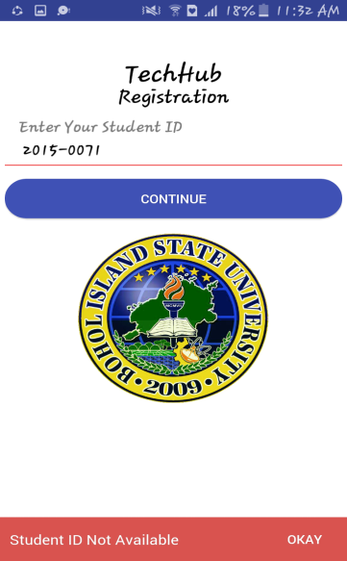

Preview 18: Enter Student ID

Test case 5: Checking Student ID

Input: Fill up with unavailable Student ID

Process: Cannot continue to sign up form

Output: Student ID not Available

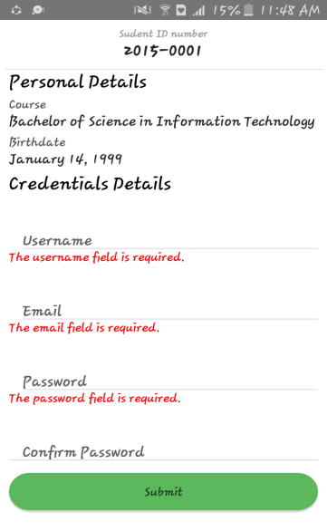

Preview 19: Register User

Test case 6: Creating an account

Scenario 1: Empty fields

Input: Fill up with an empty fields

Process: Scanning text fields

Output: All fields required

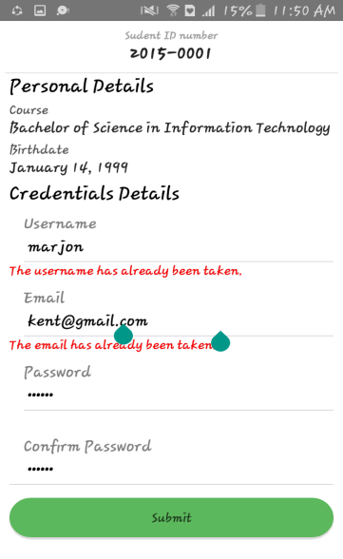

Preview 20: Register User

Scenario 2: Existing username

Input: Fill up with an existing username

Process: Scanning text fields

Output: The username has already taken



Preview 21: Register User

Scenario 3: Existing email

Input: Fill up with an existing email

Process: Scanning text fields

Output: The email has already taken

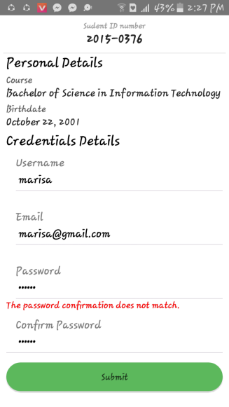

Preview 22: Register User

Scenario 4: Not the same password and confirmation password

Input: Fill up with not the same password and confirmation password

Process: Scanning text fields

Output: The password confirmation do not match

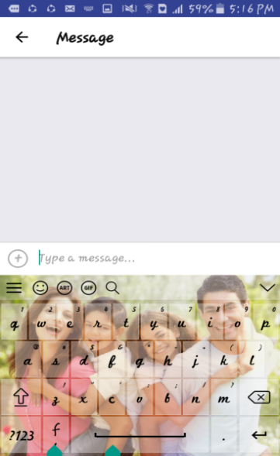

Preview 23: Sending Message

Test case 7: Send message

Scenario 1: Empty message

Input: Empty message and space bar

Process: Scanning text message

Output: Send button will not appear

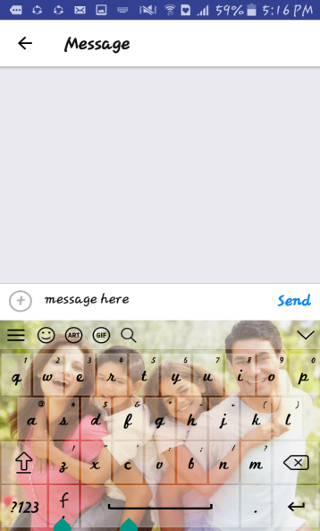

Preview 24: Sending Message

Scenario 2: Contain message

Input: Text messages

Process: Scanning text message

Output: The send button appear

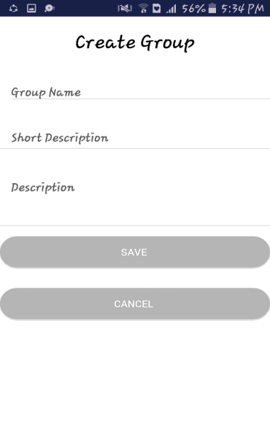

Preview 25: Create group

Test case 8: Instructor create a group

Scenario 1: Empty fields

Input: Fill up with empty fields

Process: Scanning text fields

Output: Could not create a group

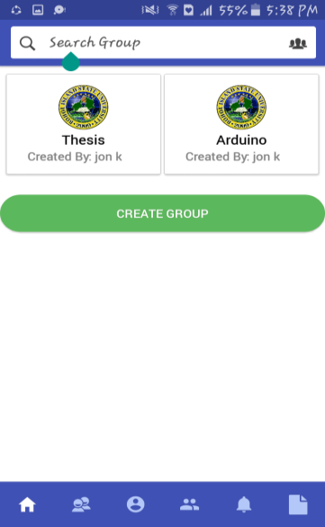

Preview 26: Create group

Scenario 2: Input all fields

Input: Fill up all fields

Process: Scanning text fields

Output: Created group appear

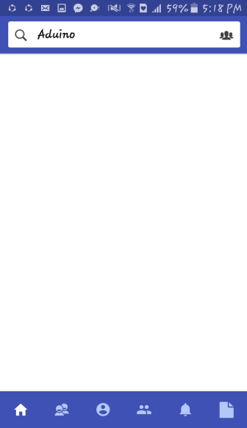

Preview 27: Search Groups

Test case 9: Search for groups

Scenario 1: Do not match to the list of groups

Input: Text that does not matches to the list of groups

Process: Scanning text in the search bar

Output: No result found

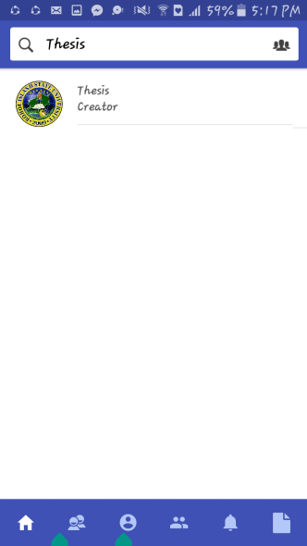

Preview 28: Search groups

Scenario 2: Match to the list of groups

Input: Text that matches to the list of groups

Process: Scanning text in the search bar

Output: Display list of matches groups



Preview 29: Search user

Test case 10: Search for users

Scenario 2: Do not match to the list of users

Input: Text that does not matches to the list of users

Process: Scanning text in the search bar

Output: No result found

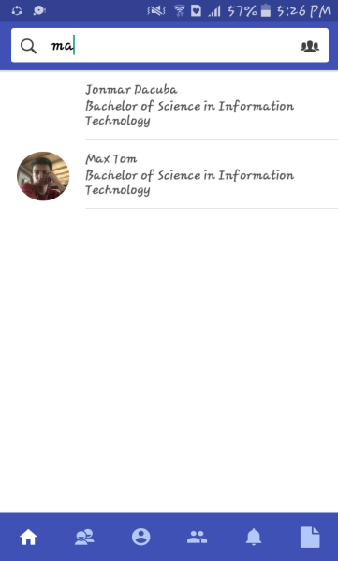

Preview 30: Search user

Scenario 2: Match to the list of users

Input: Text that matches to the list of users

Process: Scanning text in the search bar

Output: Display list of users

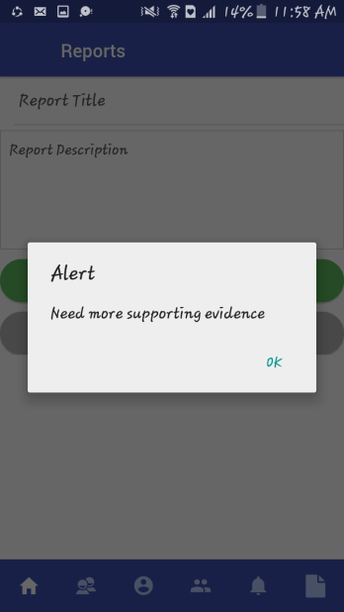

Preview 31: Report Problem

Test case11: Send Report

Scenario 1: Empty fields

Input: Fill up with empty fields

Process: Display alert dialog

Output: Need more supporting evidence

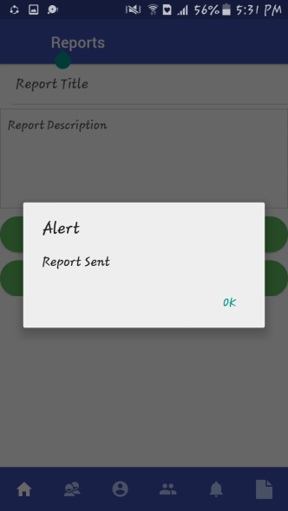

Preview 32: Report problem

Scenario 2: Input all fields

Input: Fill up all fields

Process: Display alert dialog

Output: Report sent

**Revision of the System**

First Revision:

* Username will be used in signing in
* Username that is already taken will not be used again
* Batch upload with multiple sheets
* Student ID will not be available when it is already used.
* Owner of the group can add group members
* User can comment to the announcements
* Change the error message “name already taken” into course already exists in adding course.

**Technical Requirements**

Nowadays technology adopted new innovation in which every activity will be spread all over the world. One of this is the creation of BISU Information Hub App for educational purposes.

In order to develop this study, there are three essential requirements that are needed to implement the BISU Information Hub. These are the phone ware, software and people ware. Requirements must be present and work together in newly develop system.

Phone ware is the different gadgets where the user can interacts to the application .It involves in the execution and preparation of the data in the computer. The performance of the mobile phones must be fast enough to accommodate the requirements of the application.

Software is rather referred to as set of processing information. Software is electronically stored and its function enabled the phone to work. Software categorized in two, the system software which is the android based operating system which controls and supports the operation of the computer system and application software is a program that directs the processing for the particular use of computer by the end users. Appropriate software is included in the process for the development of the system. It is the proponent for the maintenance, security, accessibility and performance of the system.

People ware utilizes the advancement of the technology; it refers to the user of the system. It is applied on the development and maintenance of the system. Creativity is integrated in the semantics and design of the system to make it readable and user-friendly.

**Hardware Requirements**

**Smartphone**. The application can be installed to any android phones for at least KitKat with API level 19 to the latest version of android phones, Random Access Memory (RAM) of 2 GB and Internal Storage of 1 GB or higher.

- The researchers had chosen the kind of specification because it is more compatible and makes the application run faster.

**Processor: Intel Core i3-6006U**

Description: Radeon Graphics

Other names: Intel(R) Core(TM) i3-6006U CPU @ 2.00 GHz 1.99 GHz

-We choose this processor because it can cater the needs of managing bulky records because the more powerful the processor is the faster the processing.

**Software Specification**

**Application Program: PHP and React Native**

This is a user friendly interface and has an easy set of command to follow. It is also a feature that would enhance user interface and data handling.

The researchers choose React Native for the proposed system in designing and developing application program. It provides different tools and features that would enhance the Graphical User Interface (GUI) and data handling.

**Database: XAMPP**

It provides a way to store and retrieve database information in both suitable and in well-organized way. It is used in the system because it is free, fast and it has a built in application such as MySQL, PHP and Apache server which is needed to communicate between the server and database.

**People ware**

People ware refers to the students and instructors in BISU Balilihan who are benefited of the application. The users specifically, who wants to know on

how to use and manipulate the BISU Information Hub app.

Cost – Benefits Analysis

In order to use and enjoy our BISU Information Hub App, user must have to purchase an Android phone to be able to install the application. And since the software is free version, user can install it to any Android phone without any charges.

**Operating Cost:**

|  |  |  |  |  |
| --- | --- | --- | --- | --- |
| ITEM | QUANTITY | UNIT | PRICE | TOTAL |
| Android Phone | 1 | Pcs. | 4000 | 2000.00 |
| Internet Data |  |  | 1000 | 1000.00 |
| Bond Paper | 1 | Ream | 170 | 170.00 |
| Sliding Folder | 3 | Pcs. | 12 | 36.00 |

Interface Design

Object ID: Form 1

Object Description: Admin Log-in form

**A. GENERAL DESCRIPTION**

A form where the admin can input the email address and password to access the web application.

**B. PROGRAM SPECIFICATION**

Login - tap to go to Main Menu

Username- used to input username

Password- used to input password

Username – display username label

Password – display password label

**C. SCREEN LAYOUT**

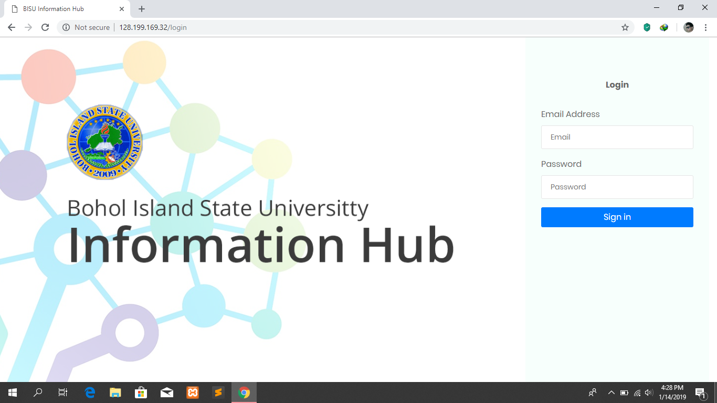

Preview 33: Admin Log in Form

Object ID: Main Menu

Object Description: View Menus

**A. GENERAL DESCRIPTION**

Main menu displays the different menus of the web application.

**B. PROGRAM SPECIFICATION**

Announcements – click to go to Announcements

Manage Group – click to manage groups

Teachers – click to manage Teachers

Upload ID – click to upload ID

Manage groups – click to manage groups

Manage User – click to manage users

Reports – click to view reports

Sign-out – click to sign-out

**C. SCREEN LAYOUT**



Preview 34: Main Menu

Object ID: Announcements

Object Description: View general announcements

**A. GENERAL DESCRIPTION**

Manage and display the general announcements.

**B. PROGRAM SPECIFICATION**

Add button – to add/create new announcements

Simple button task – to edit or delete announcements

Search button – search for announcements

**C. SCREEN LAYOUT**

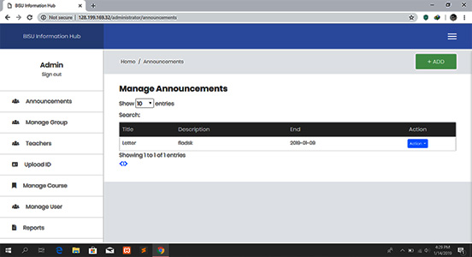

Figure 35: General Announcements

Object ID: Teachers

Object Description: View Teachers

**A. GENERAL DESCRIPTION**

Manage and display the list of registered teachers and there information

**B. PROGRAM SPECIFICATION**

Add button – to add/registered new teacher

Search button – search for teachers

Show dropdown button – to set the minimum entries you will be able to sshow

Simple Button Task:

Edit – to edit data

Delete – to delete data

**C. SCREEN LAYOUT**

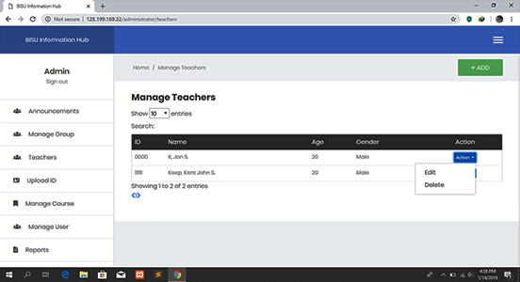

Figure 36: Registered Teachers

Object ID: Students

Object Description: View Students information

**A. GENERAL DESCRIPTION**

Manage and display the list of students with their corresponding School ID

**B. PROGRAM SPECIFICATION**

Add button – to add/upload new School ID

Batch upload button – to add/upload multiple ID

Search button – search for Student ID

Show dropdown button – to set the minimum entries you will able to show

Simple Button Task:

Edit – to edit data

Delete – to delete data

**C. SCREEN LAYOUT**

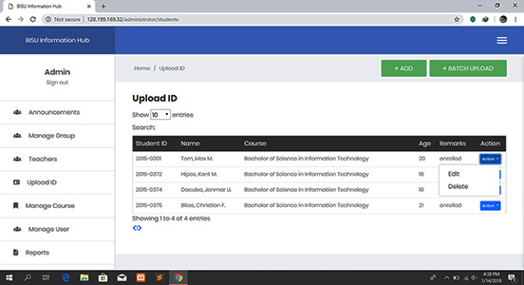

Figure 37: Students

Object ID: Manage Course

Object Description: View All Courses

**A. GENERAL DESCRIPTION**

Manage and display the list of all courses

**B. PROGRAM SPECIFICATION**

Add button – to add new course

Search button – search for course

Show dropdown button – to set the minimum entries you will able to show

Simple Task Button:

Edit – to edit data

Delete – to delete data

**C. SCREEN LAYOUT**

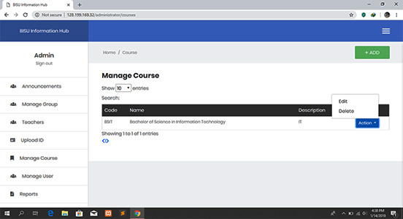

Figure 38: Manage Course

Object ID: Manage User

Object Description: View All Users

**A. GENERAL DESCRIPTION**

Manage and display the list of all users

**B. PROGRAM SPECIFICATION**

Add User button – to add new user

Search button – search for users

Show dropdown button – to set the minimum entries you will able to show

Simple Button Task:

Edit – to edit data

Block – to block a user

**C. SCREEN LAYOUT**

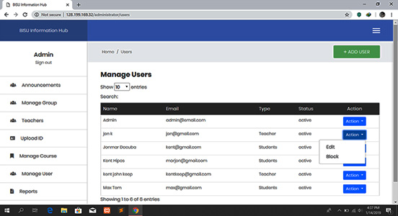

Figure 39: Manage Users

Object ID: Reports

Object Description: View Report Issues

**A. GENERAL DESCRIPTION**

Display all report issues.

**B. PROGRAM SPECIFICATION**

Search button – search for announcements

Show dropdown button – to set the minimum entries you will able to show

Simple Task Button:

Details – to view report details

**C. SCREEN LAYOUT**

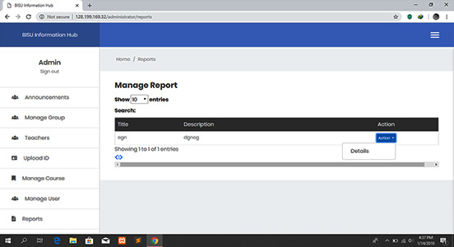

Figure 40: Manage Report

Object ID: Login

Object Description: User Log-in Form

**A. GENERAL DESCRIPTION**

A form where a registered user can input the username and password to access the mobile application.

**B. PROGRAM SPECIFICATION**

Login – tap to go to main menu

Username or email – used to input username or email

Password – used to input password

Signup – tap to create new account

Username or email label – display username or email label

Password label – display password label

**C. SCREEN LAYOUT**

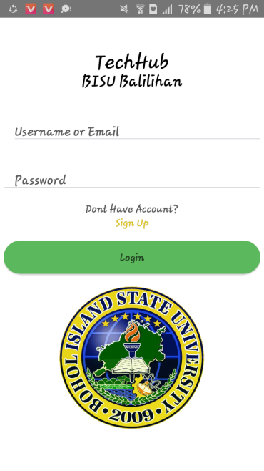

Preview 41: User Log-In Form

Object ID: Home

Object Description: View Messages

**A. GENERAL DESCRIPTION**

Display created conversations

**B. PROGRAM SPECIFICATION**

Conversation – tap to view messages

Messages label – display messages label

**C. SCREEN LAYOUT**

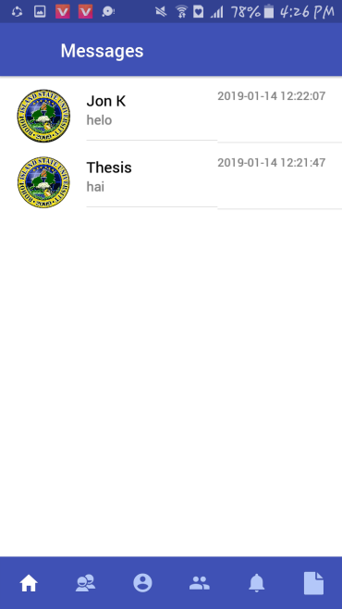

Preview 42: Home Form

Object ID: Creating Conversation

Object Description: Send and receive messages

**A. GENERAL DESCRIPTION**

Allow the user to create conversations.

**B. PROGRAM SPECIFICATION**

Type message – use to input messages

Add icon – click to select images to send

Send – click to send message and image

Back button – click to go back to previous page

**C. SCREEN LAYOUT**

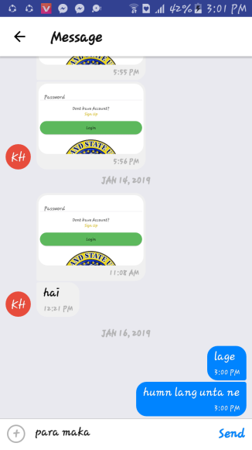

Preview 43: Creating conversations

Object ID: Group

Object Description: View Groups

**A. GENERAL DESCRIPTION**

Display groups that you have been joined

**B. PROGRAM SPECIFICATION**

Group name – tap to view group messages, group announcements and group members

Search icon – tap to search for groups

**C. SCREEN LAYOUT**



Preview 44: Group Form

Object ID: Group Preview

Object Description: Preview Groups for group members

**A. GENERAL DESCRIPTION**

Display group conversations, group announcements and members

**B. PROGRAM SPECIFICATION**

Chat – tap to view group conversations

Announcements – tap to view group announcements

Members – tap to view group members

**C. SCREEN LAYOUT**

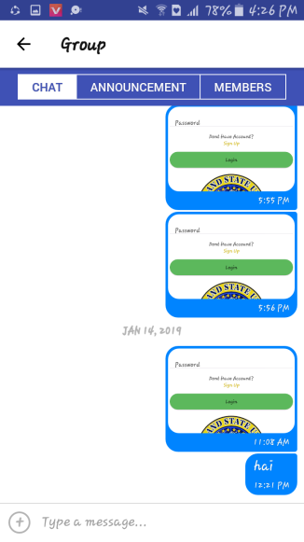

Preview 45: Group Preview for group members

Object ID: Group Preview

Object Description: Preview Groups for the owner

**A. GENERAL DESCRIPTION**

Display group conversations, group announcements, members and request

**B. PROGRAM SPECIFICATION**

Chat – tap to view group conversations

Announcements – tap to view group announcements

Members – tap to view group members

Kick button – click to kick members

Add members button – click to add members

Request – tap to view group request

**C. SCREEN LAYOUT**

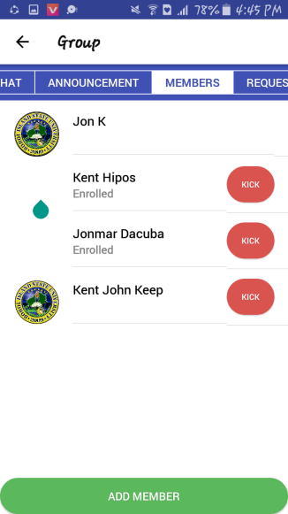

Preview 46: Group Preview for group owner

Object ID: Profile

Object Description View Profile

**A. GENERAL DESCRIPTION**

Display persons profile

**B. PROGRAM SPECIFICATION**

Logout button – tap to go back into login form

Personal details – display personal details

**C. SCREEN LAYOUT**

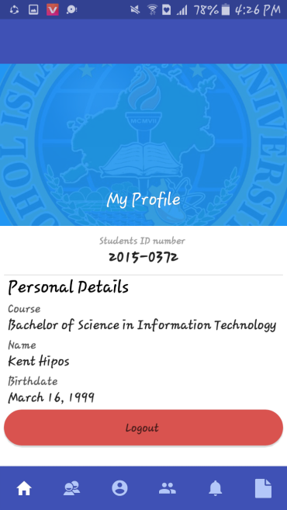

Preview 47: Profile Form

Object ID: Friends

Object Description: View List of Friends and Friend Request

**A. GENERAL DESCRIPTION**

Display list friends and friend request

**B. PROGRAM SPECIFICATION**

Accept button – tap to accept friend request

Decline button – tap to decline friend request

Friends list – tap to view friend’s profile

Search icon – tap to search for friends

**C. SCREEN LAYOUT**

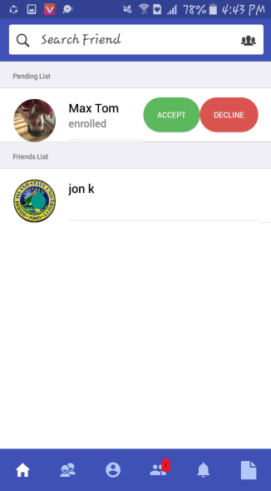

Preview 48: Friends Form

Object ID: General Announcements

Object Description: View List of General announcements

**A. GENERAL DESCRIPTION**

Display list of general announcements

**B. PROGRAM SPECIFICATION**

Announcements – display announcements label

View – tap to view content

**C. SCREEN LAYOUT**

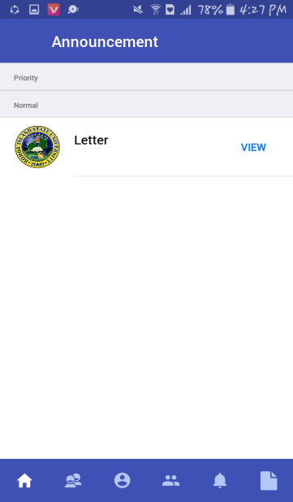

Preview 49: General Announcements Form

Object ID: Announcement Preview

Object Description: View Content of the announcement

**A. GENERAL DESCRIPTION**

Display content of the announcement

**B. PROGRAM SPECIFICATION**

Back button – to go back to previous page

File Attachment – click to download attachment

Write comment – to write a comment to the announcement

Comment button – to send the comment

**C. SCREEN LAYOUT**

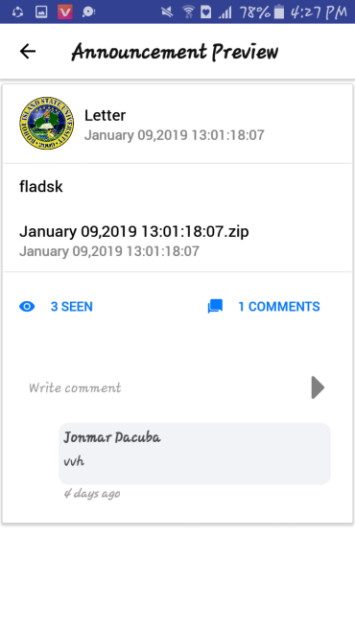

Preview 50: Announcement Preview Form

Object ID: Report Problem

Object Description: Send Report

1. **GENERAL DESCRIPTION**

Display form in reporting a problem

1. **PROGRAM SPECIFICATION**

Report Title – input report title

Report Description – input report description

Add Screenshot button – to add image as supporting evidence

Submit button – to send the report

1. **SCREEN LAYOUT**

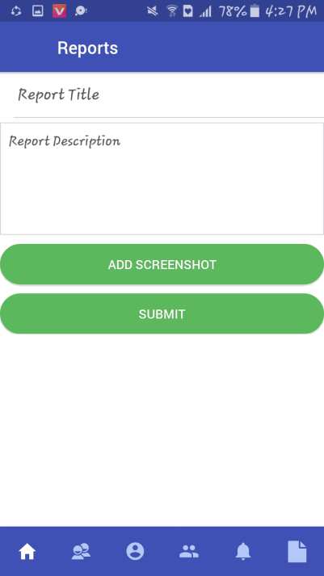

Preview 51: Report Problem